Guidelines for creating calibration forms

- All font should be Calibri and its size should be 11, except form title and note
- Note font size should be 9
Title color
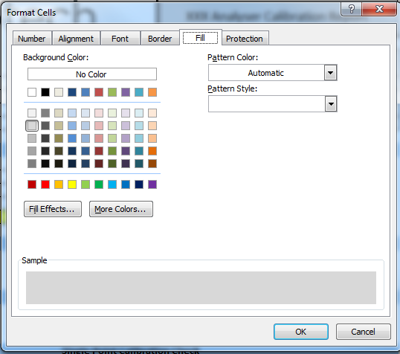

- Date format should be
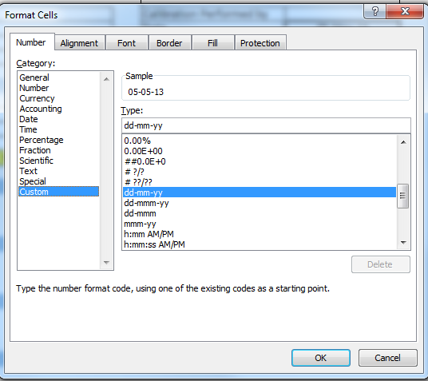

- Time format should be
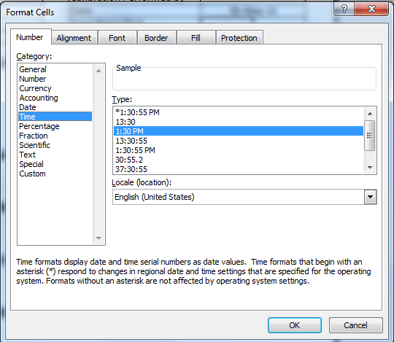

- All headers or banners should be bald and filled with color
Header or banner color
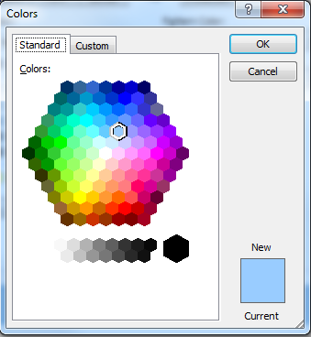

- All forms should include pre-calibration and post calibration
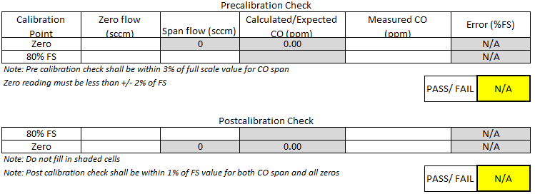

- Try and use the same formula setup and layout for the cylinder calibration pass/fail section (based on date) on all forms
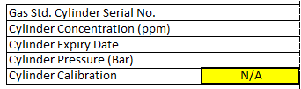

- All PASS/FAIL sections should be locked. Use conditional formatting to make the colors change for Pass/Fail statement
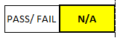

- For “PASS” condition color
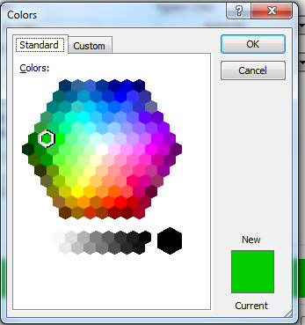

- For “FAIL” condition color
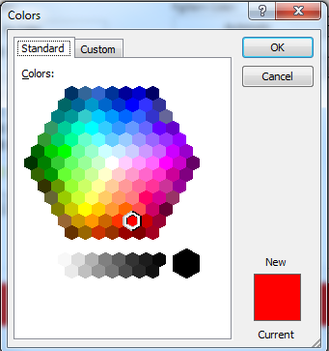

- For “N/A” condition color
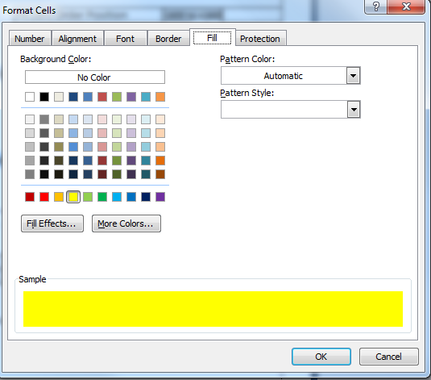

- All formula cells should be locked and filled with color.
Formula cell color


- Try and make formula cells go blank when not used rather than say Division by Zero or other error messages. N/A is fine of course.

- Use the below formulas for error and concentration calculation
- Calculated concentration = (Span Flow x Gas bottle concentration (ppb)) ÷ (Span Flow + Zero flow)
- Error is: (measured - calculated)
- Error as % Point is: (measured-calculated) ÷ calculated x 100
- Error as % of full scale is: (measured-calculated) ÷ (instrument full scale) x 100

- Use the below formula for standard error, R-square and intercept calculation

Standard error = (STEYX(Y_values,X_values))/full scale value

R-square value = RSQ(Y_values, X_values)

Intercept value = INTERCEPT(Y_values,X_values)

Please note STEYX, RSQ and INTERCEPT functions are built in EXCEL

- For single point, ensure the Pass/fail criteria for each gas is matched our standard gas analysers
Eg Nox
- Pre calibration check shall be within 5% of FS value for NOx span
- Zero values should be within 2% of Full Scale
- Post calibration check shall be within 1% of FS value for both NOx span and all zeros

- For the multi-point, ensure the PASS/FAIL criteria for each gas is matched our standard gas analysers
Eg Nox
Final Zero must be within 1% of FS,
Standard error of y about x must be < 1%FS

- Ensure the number of points required for each gas for multipoint is matched our standard

- The page layout should have the same margins as other forms. The page percentage scaling should be 100% wherever possible.
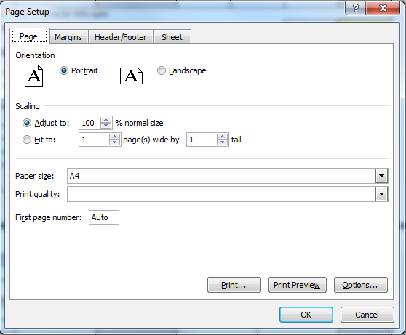

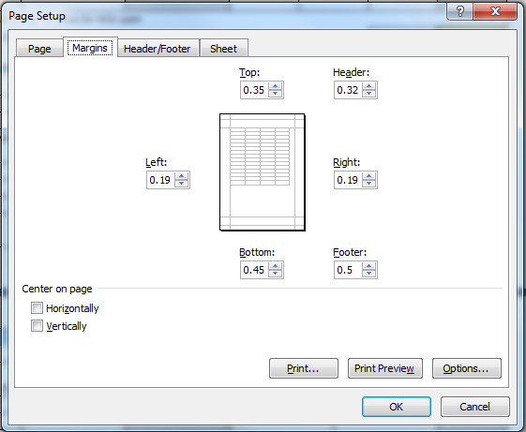

- All text label alignment should be set to Left or center and bottom
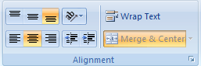

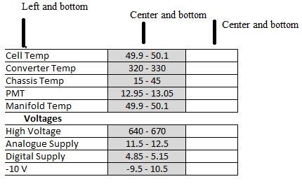

- Use spin control for listing

- Signature and date section should be like this.

- Keep all columns to the same size as possible (do not manually resize column). Use merge feature to create bigger column area
- Make sure you check how it looks when you print it off. Ensure all modified /edited cells are within printed area. Use print preview to check
- Try and make the form flows so that technicians do things in the correct order
- Try keeping the form as neat and clear as possible. Add things that you believe they are important

Caroline

